Exporting Pin Assignments in Quartus
- If not already done, compile Quartus project.

- Go to Assignments Export Assignments

- Navigate to the path of the .qsf file in the Quartus project (this should be set correctly by default), then click OK to export. Allow Quartus to create a new directory if prompted.

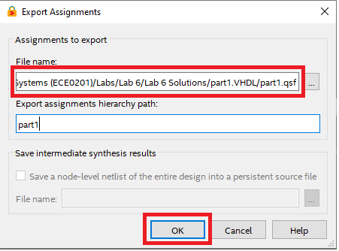

- Verify the .qsf file has been placed in the created directory. This file can now be imported into future Quartus projects.
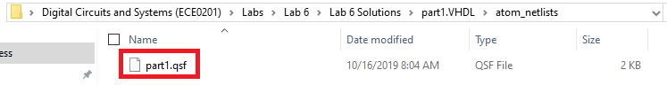

Importing Pin Assignments in Quartus
NOTE: Importing pin assignments should be done before other pin assignments have been added to a new Quartus project.
- Go to Assignments Import Assignments

- Click on “…” to open File Explorer, navigate to your exported .qsf file, and select.
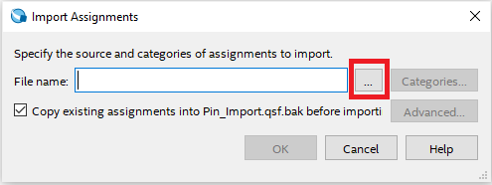

- Once the .qsf file is selected, click Advanced.
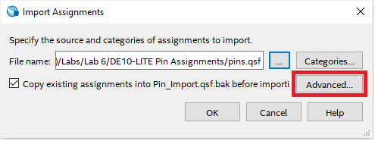

- In Advanced Import Settings, select the “Global assignments from another project” radio button, then click OK.
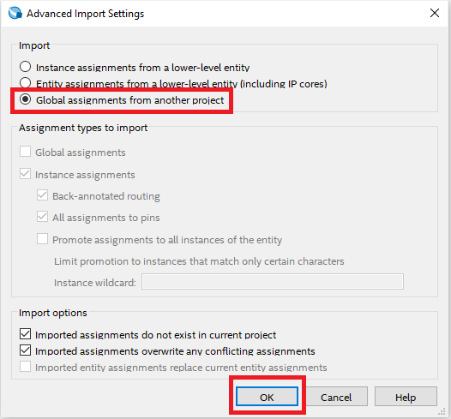

- In the Import Assignments window, click OK.
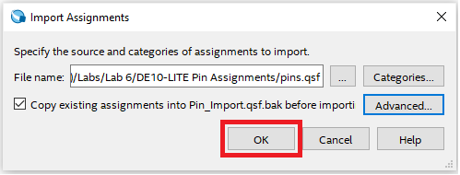

- Verify import is completed in the Messages window.

- Verify import is successful in the Pin Assignment Editor.

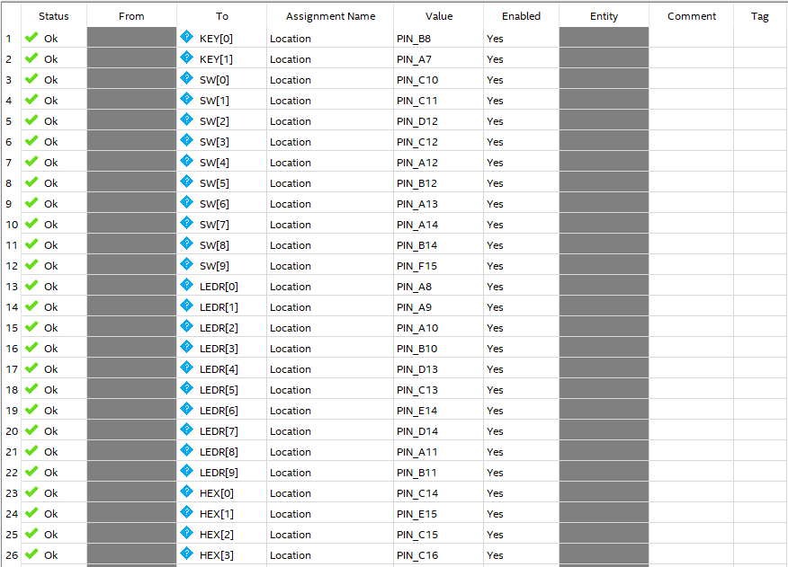

- NOTE: The port names used in the .qsf file will need to be changed to match the port names used in your project, unless you choose to use the port names used in the imported .qsf file.

